**About This Document**

This document is a mixture of a software design specification for the software module “OPC UA” – which performs many aspects of data transfer and data manipulation when pulling data from a remote OPC server.

**Setup**

Depending whether this should be part of QiaService like a plugin or standalone application differs app setup

Run app using .exe file and configure app behavior in qia.opc folder

Also, you can run from IDLE and just set QIA.Plugin.Opc as startup

**Configuration**

In appsettings.json - main app configuration

• OpcUrl

• DB connection string

• AzureEventHub credentials

- advanced configuration:

• SaveToDb - save static values to db

• SaveToAzure - send data to eventhub

• RecreateDb - if we want to drop db and recreate

nodemanager.json - configuration to lookup for particular nodes on the server

• NodeId

• Name - custom node name

• NodeType - if equals to Subscription will be monitoring value on the server by accepting events

• Range - how many nodes to skip and then save to the DB

• Msecs - how often save to db

AppConfig.json - defines minor configuration when searching for nodes

• Name - (Initial/Advanced/Slim) app pulls the last one from the settings

• SkipPredefined - skips data like ServerStatus/Aliases

• CreateFullTree - if we want full tree to be created

**Logging**

Currently Serilog+Seq is used. Logs are saved locally and also sends to the http://localhost:5341

// will be modified in future

# OPC ua simulator

## Intro

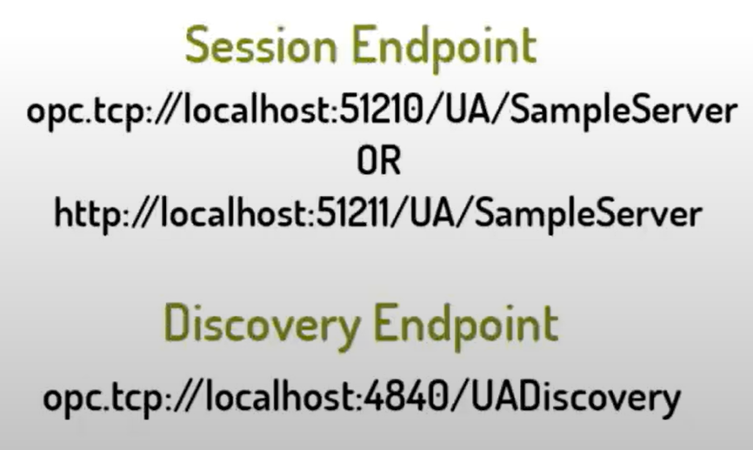

[Source](https://www.youtube.com/watch?v=vgE9P6KNC7g)

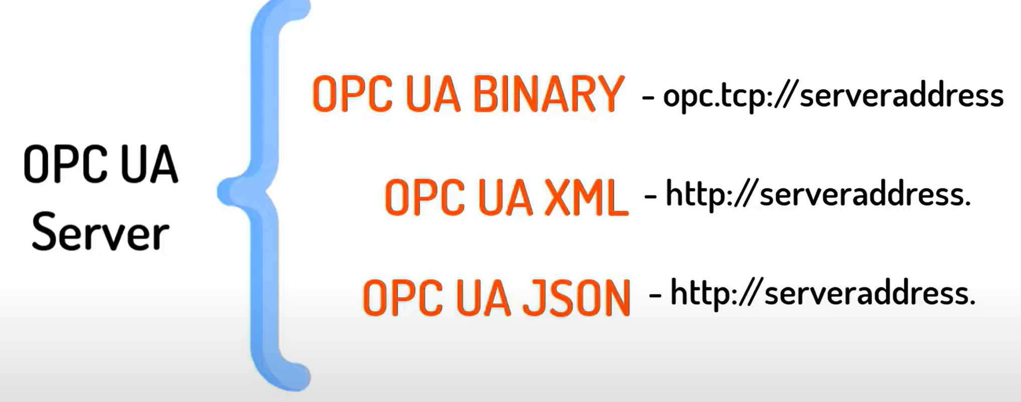

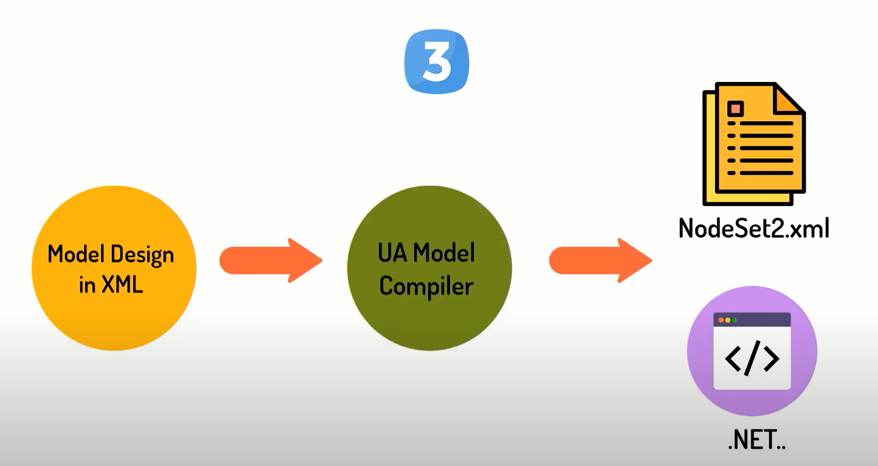

[Source](https://www.youtube.com/watch?v=gxA7SDNLHgc&list=PLIrJJXPVFRvjHsA9tta8yULOB8nPUO_G7&index=5)

<https://www.youtube.com/watch?v=yCd2j2WsgBM>

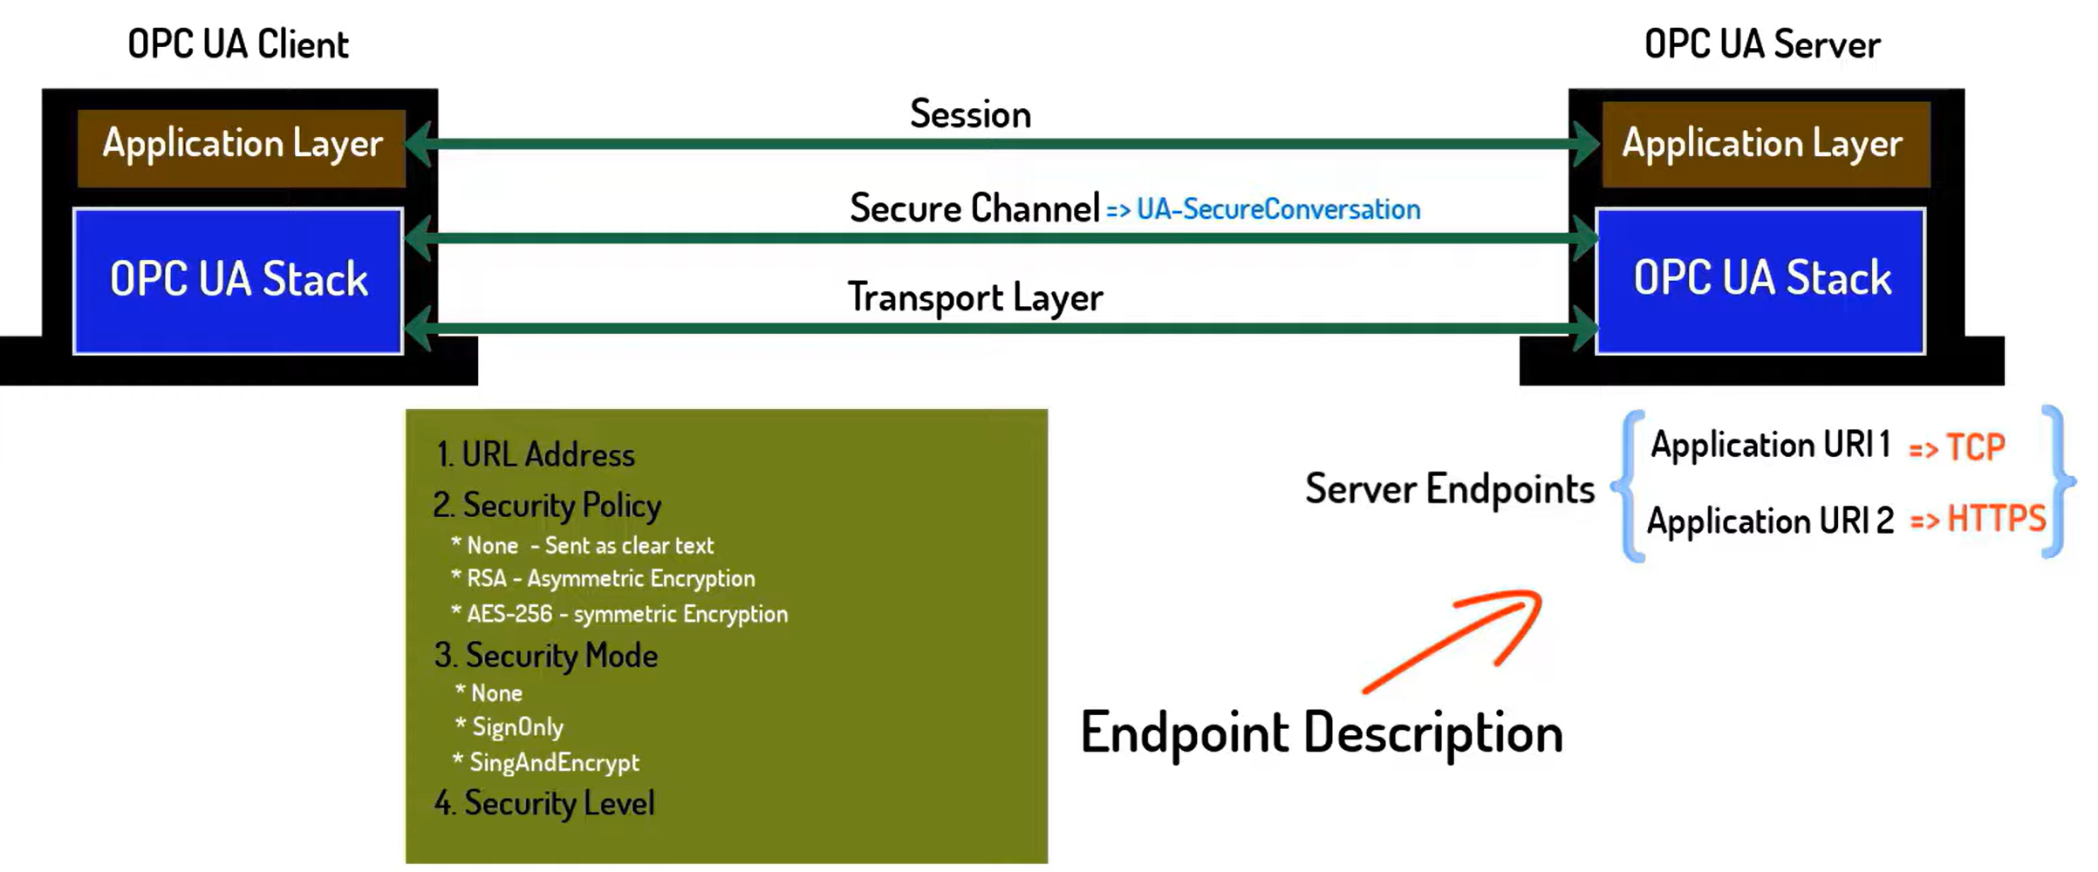 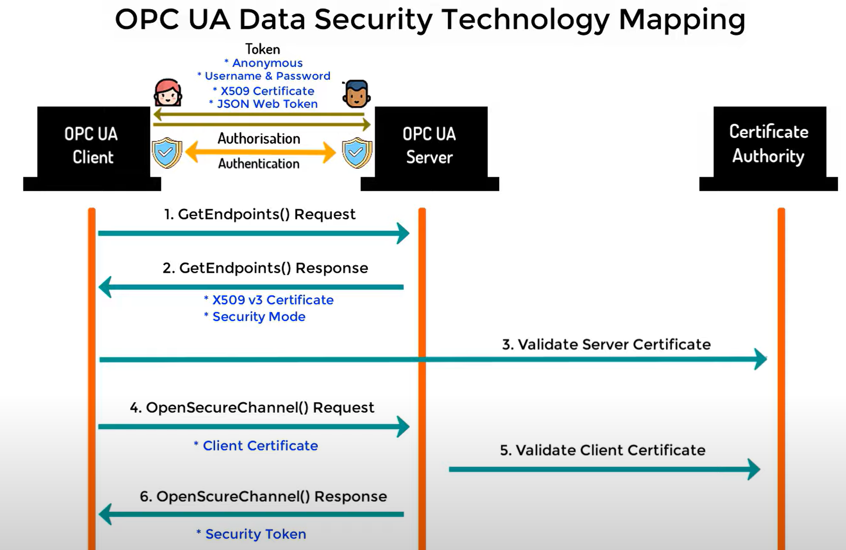

<https://opcua.rocks/step-3-setup-visual-studio-to-edit-opc-ua-modeldesign-files/>

<https://opcfoundation.github.io/UA-.NETStandard/help/index.htm#ua_sample_client.htm>

<https://cache.industry.siemens.com/dl/files/088/42014088/att_954894/v1/42014088_OPC_UAClient_DOKU_V12_en.pdf>

Node with attribute NodeId and value ns=3 ;s=Counter is unique and automatically generated identifier

ns is a namespace index

## Agenda

1. Run OPC UA on Docker
2. ...and on WIN10 Client as well
3. OPC UA Server as well
4. Communicate server and client

x. change tcp to https

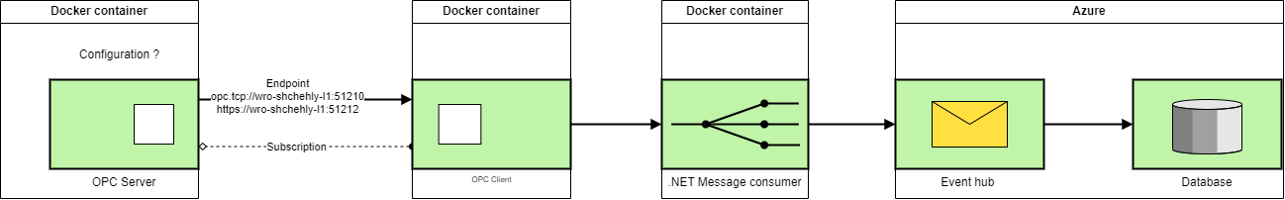



### Sample solutions

* <https://hub.docker.com/_/microsoft-iotedge-opc-client>
* <https://hub.docker.com/_/microsoft-iot-opc-ua-test-server>
* <https://hub.docker.com/_/microsoft-iotedge-opc-plc>
* <https://github.com/Azure-Samples/iot-edge-opc-client>
* <https://github.com/Azure-Samples/iot-edge-opc-plc>

Reference

* <https://github.com/OPCFoundation/UA-.NETStandard-Samples>

Red are working console solutions

### Write together your outcome to a "whitepaper"

🡺 way you got there

🡺 Pitfalls

🡺 Documentation (brief) for developer

🡺 whitepaper: aspect Docker setup

## Solution



### Intro, new solution

<https://integrationobjects.com/sioth-opc/sioth-opc-unified-architecture/opc-ua-server-simulator/>

<https://opcfoundation.github.io/UA-.NETStandard/help/index.htm#client_development.htm>

* [Install Docker Desktop on Windows | Docker Documentation](https://docs.docker.com/desktop/install/windows-install/)
  + [Limiting Memory Usage in WSL2 | Aleksandr Hovhannisyan](https://www.aleksandrhovhannisyan.com/blog/limiting-memory-usage-in-wsl-2/)

### Certificate

[Certificate Store Directory Layout](https://reference.opcfoundation.org/v104/GDS/docs/F.1/)

[OPC UA Certificate Stores](https://opclabs.doc-that.com/files/onlinedocs/QuickOpc/Latest/User's%20Guide%20and%20Reference-QuickOPC/Certificate%20Stores.html)

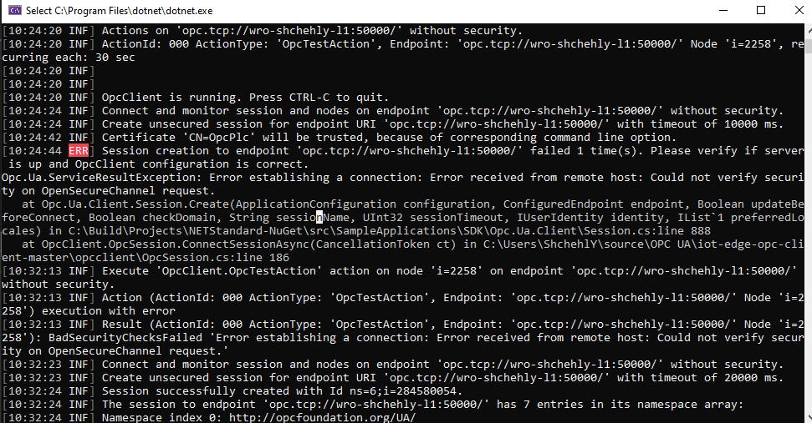

Copy from opc_client\...\pki\own\certs to opc_server \...\pki\trusted\certs and oposite for client and delete form pki\rejected\certs

**Lunch** client with --at X509Store arguments

Check the Program.cs:61 DefaultEndpointUrl

Result: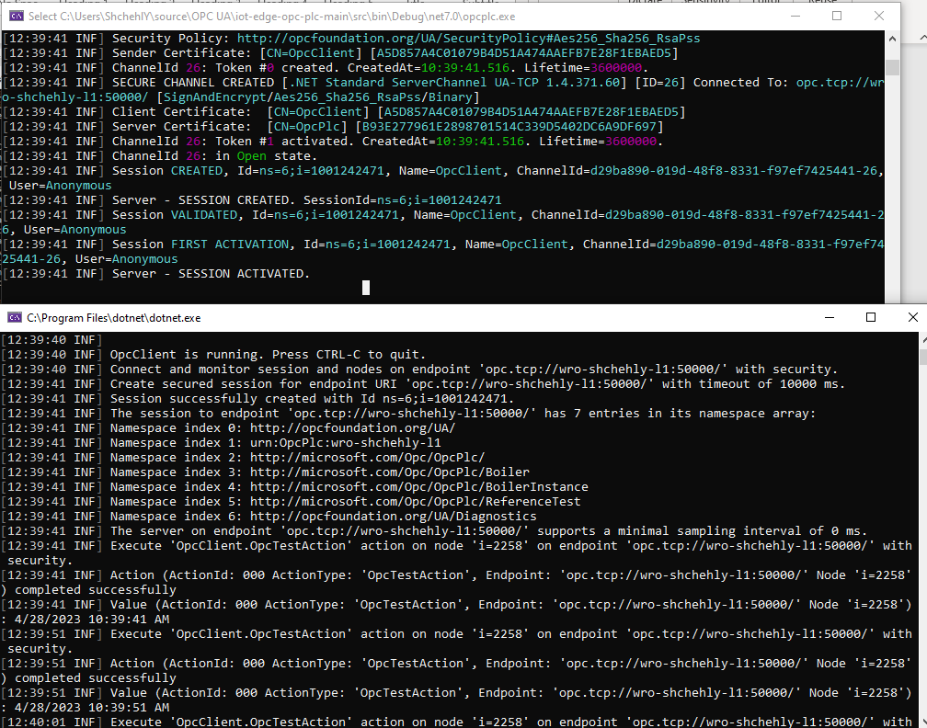

### Data generating

* Create custom ModelDesign.xml like <opc:Object> and convert the file using UA-ModelCompiler to c# class.
* 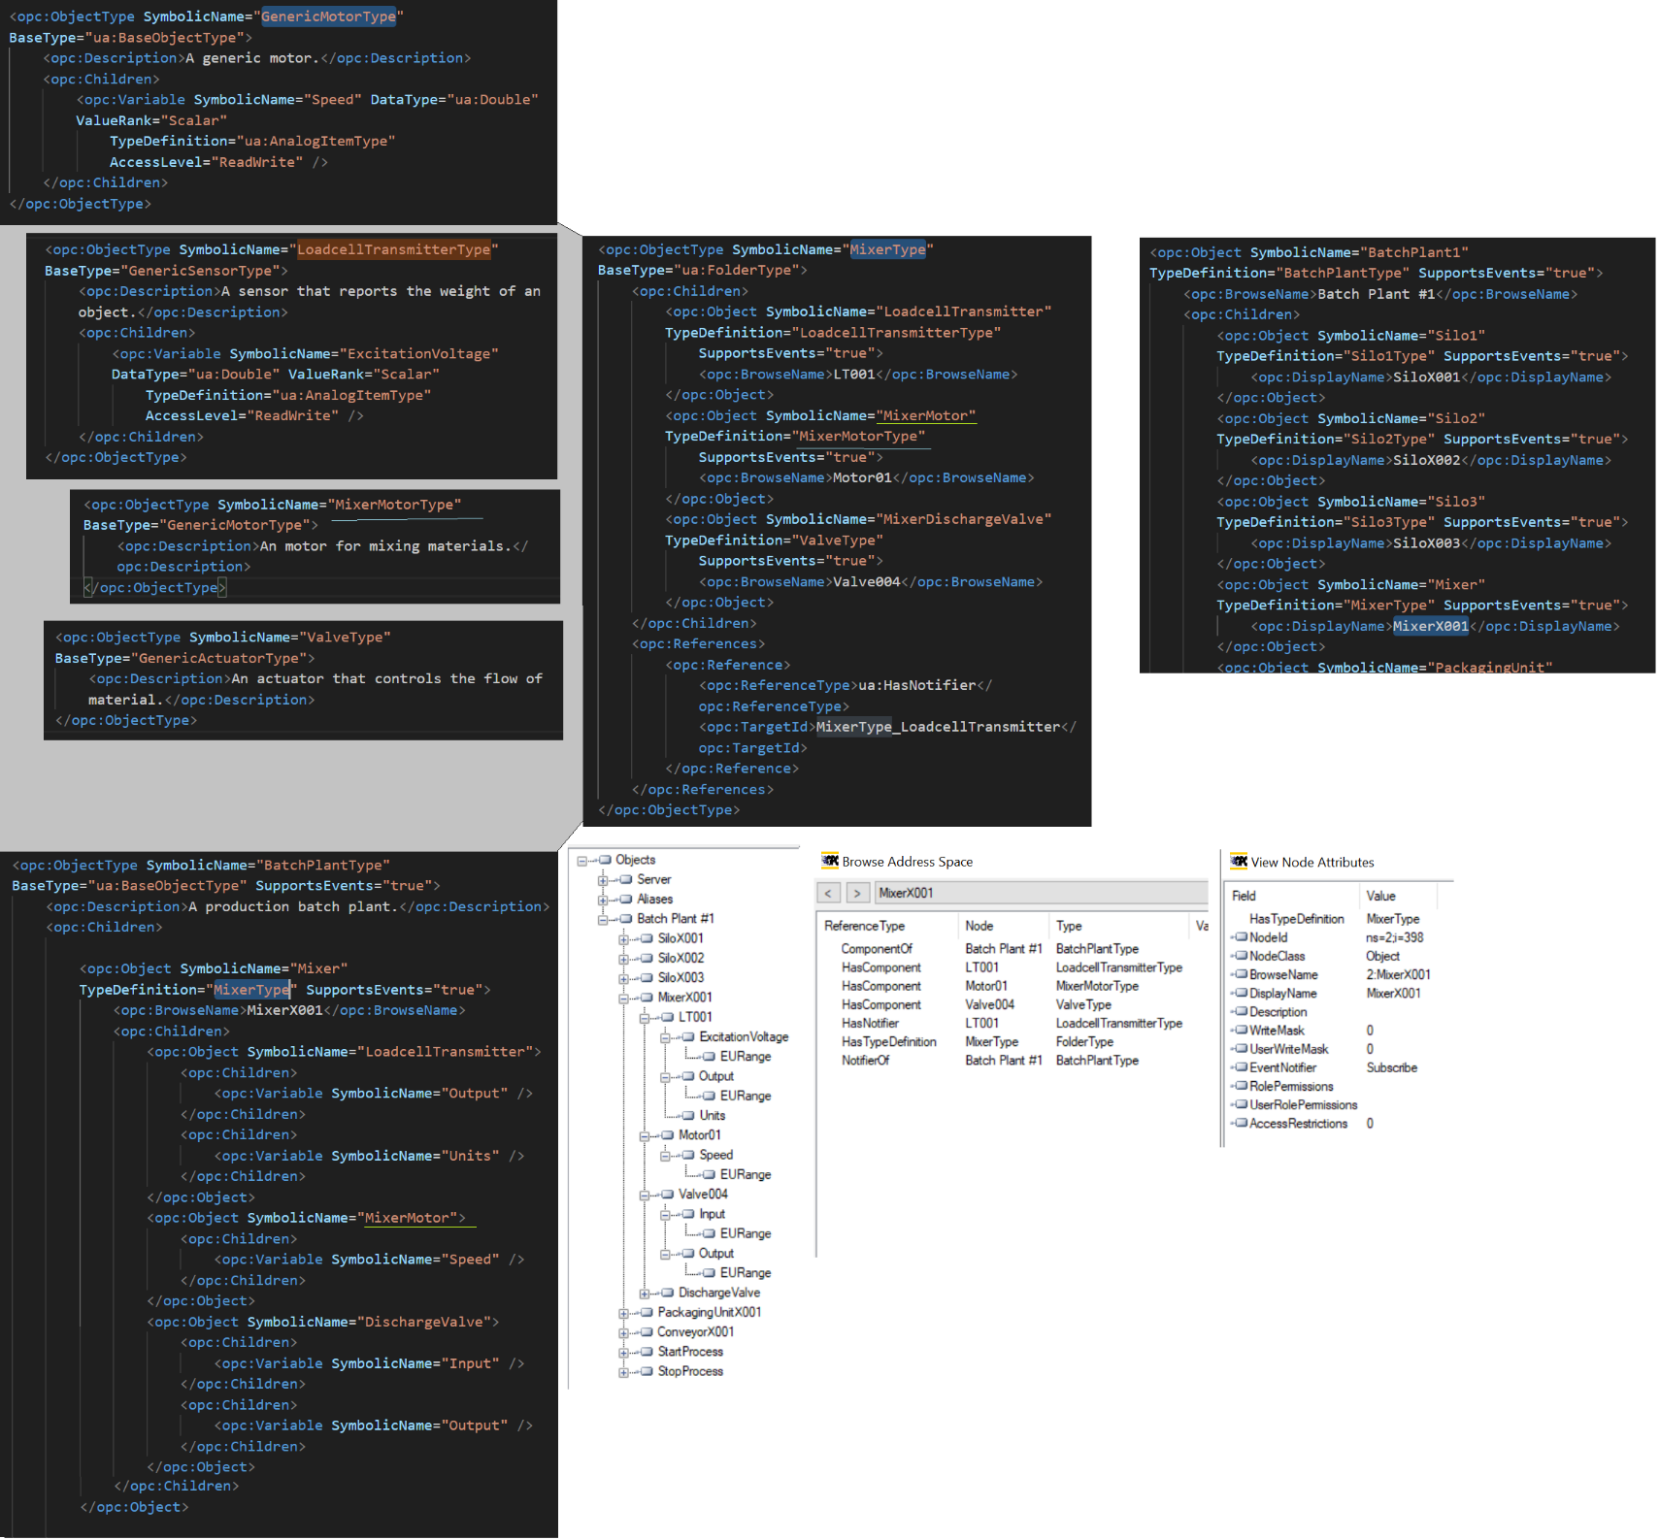
* <https://github.com/OPCFoundation/UA-ModelCompiler> clone and build release
* .\Opc.Ua.ModelCompiler.exe -d2 C:\Models\ModelDesign.xml -cg C:\Models\ModelDesign.csv -o C:\Models -console -version v104
* Sample server config: 
* Copy all the generated content into ~\Data and start the server

## Opc as a worker

**Qia.Service**

* Command line arguments:

appSettings=Databases,Assemblies,Logging,Logins,Workers.OpcUa appControl=appControl configDir=C:\QIA.Service.TEST\config

* Worker configuration:

 Check your “Location” in json

**Qia.OpcClient**

The main class (e.g. Program.cs) should derive from QIA.Library.Worker.QIAWorker abstract class and Init() method should start the worker.

## Servers

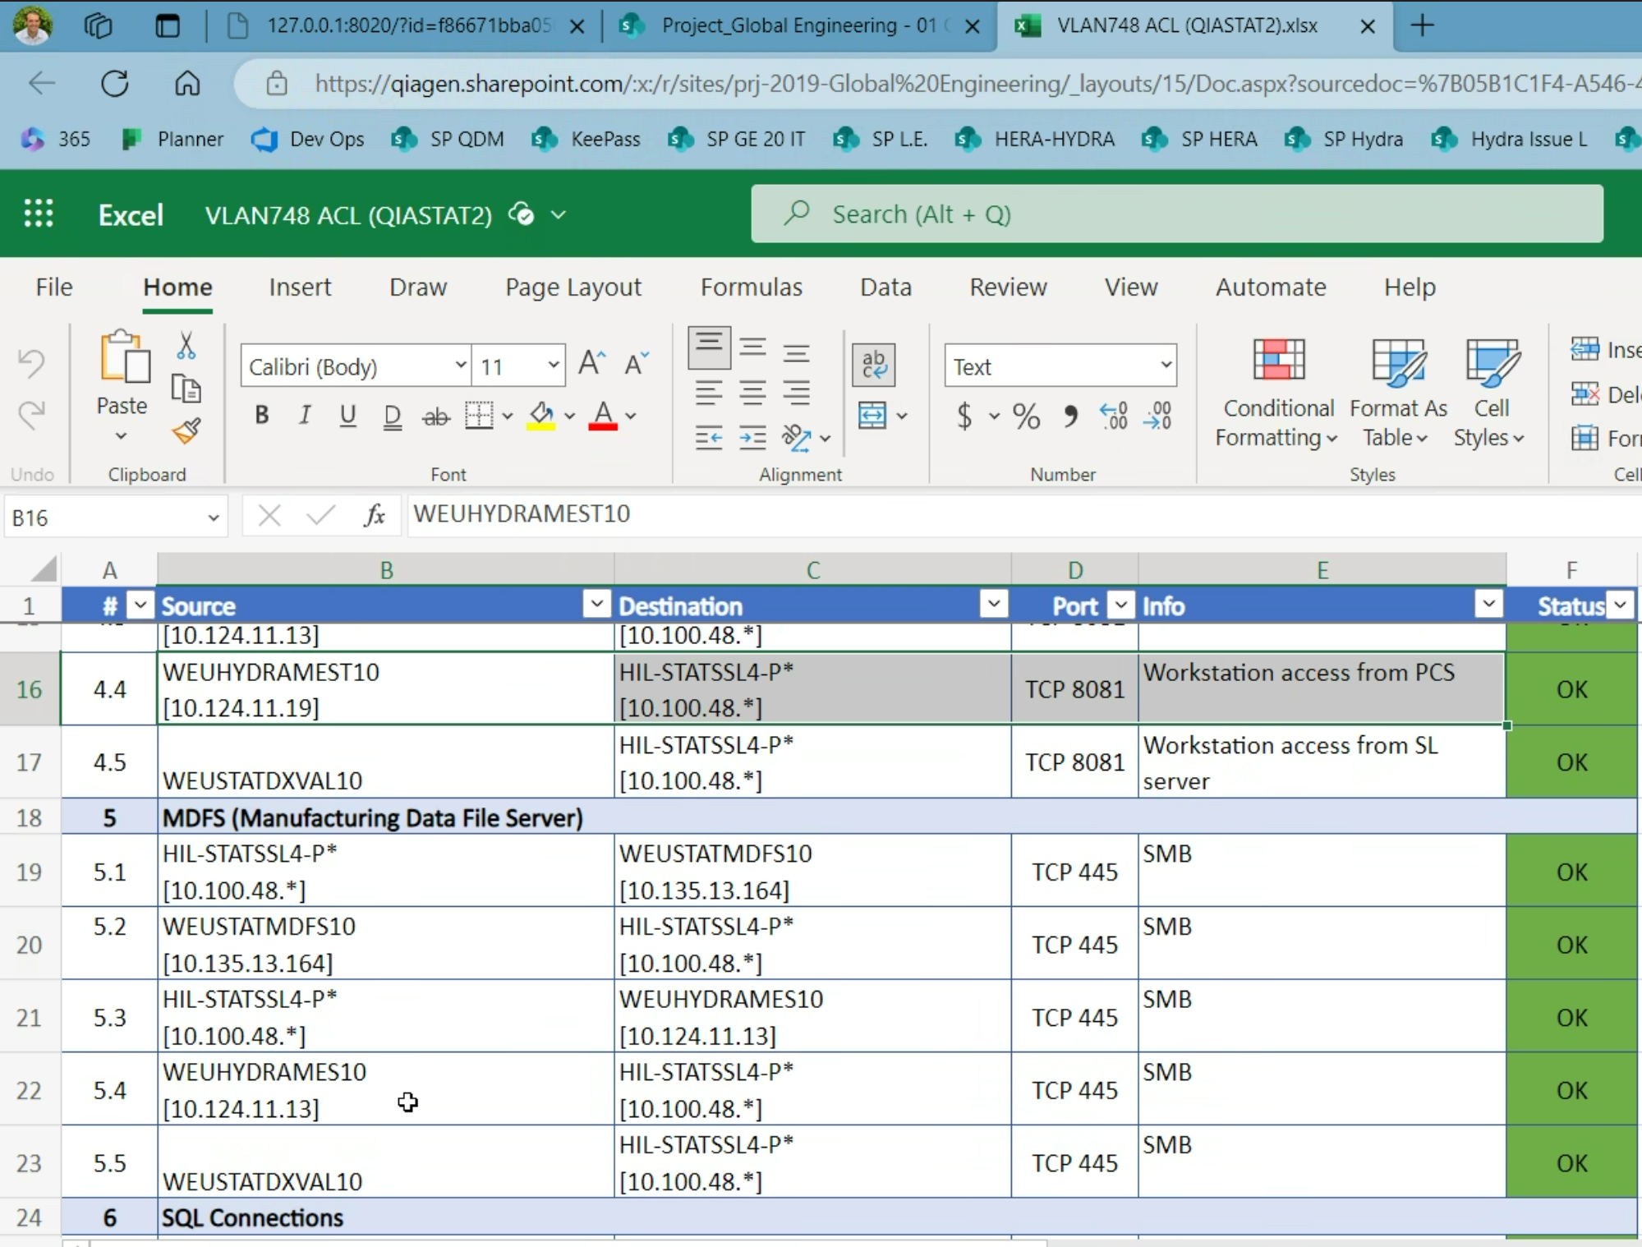

**Micron**:

WEUHYDRAMESt10

opc.tcp://10.100.48.100:4981

|  |
| --- |
| WEUSTATDXPROD10  WEUSTATDXDEV10  WEUSTATDXTEST10 |

--> cause we renamend the VAL to PROD

port for OPC UA is

TCP 4840

**Richiger**:

WEuhydrames10

## Troubleshooting

* “*waiting for WSL integration for Ubuntu: waiting for WSL distro integration to become ready in "Ubuntu": timeout*”

wsl --shutdown

wsl --update

* cannot update ubuntu or install packages

1. Make sure your VPN is open
2. If still, write to IT Support to check restrictions

## Architecture

Qia.Opc..API

|-------> Qia.Opc..Services

| |-------> Qia.Opc..OPCUAConnector

| | |-------> Qia.Opc..Common

| |

| |-------> Qia.Opc..Persistence

| |-------> Qia.Opc..Common

|

|-------> Qia.Opc..Common

1. Connect to opc server by providing url